**PDA:** **Software** **Development Level** **8**

**Student:** David Sanchez Rodriguez

**EVIDENCE: UNIT I & T**

**Ref:** I.T. 5

Demonstrate the use of an array in a program.

* An array in a program

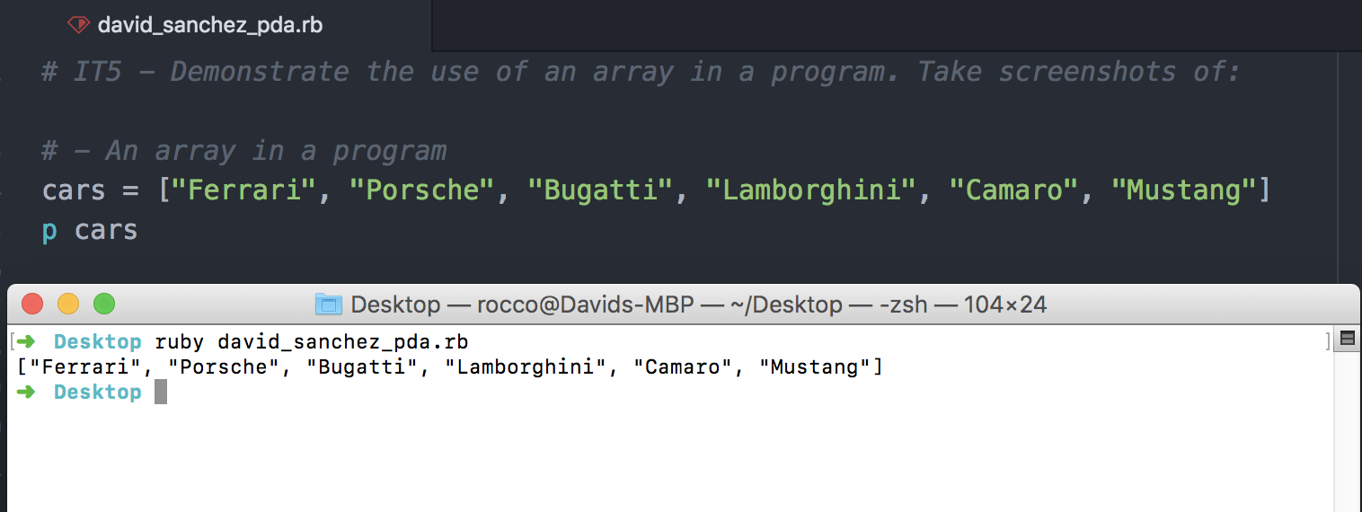

* A function that uses the array

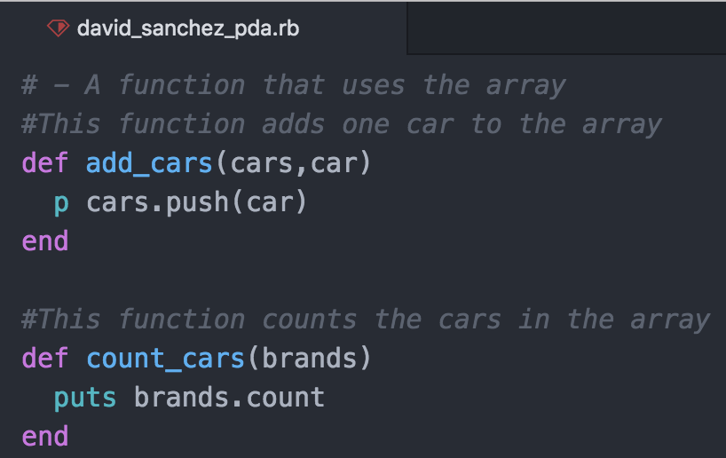

* The result of the function running

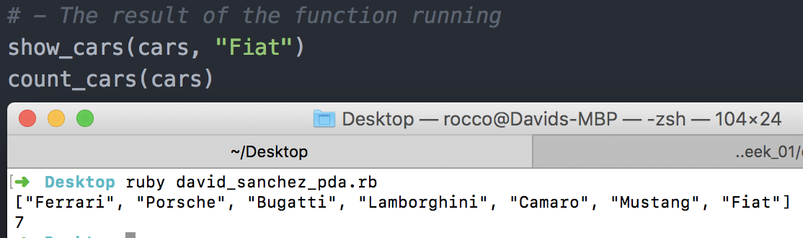

**Ref:** I.T. 6

Demonstrate the use of a hash in a program.

* A hash in a program

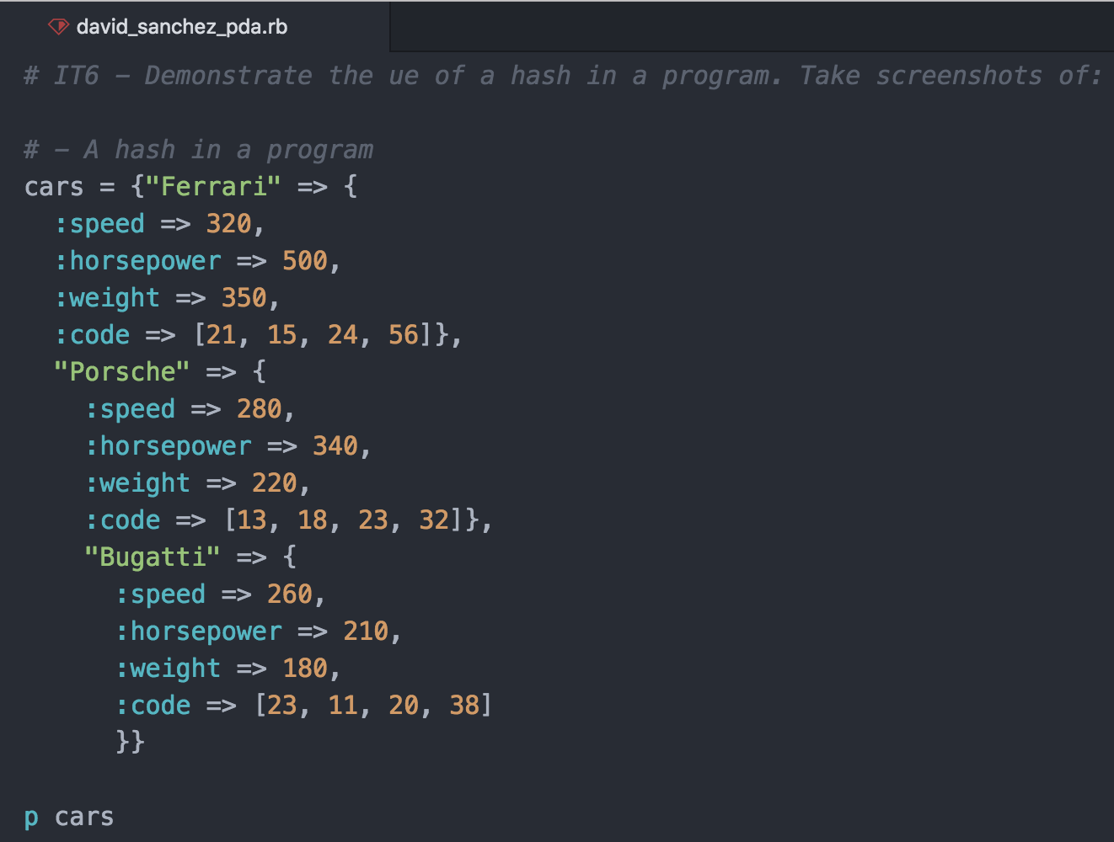

* A function that uses the hash

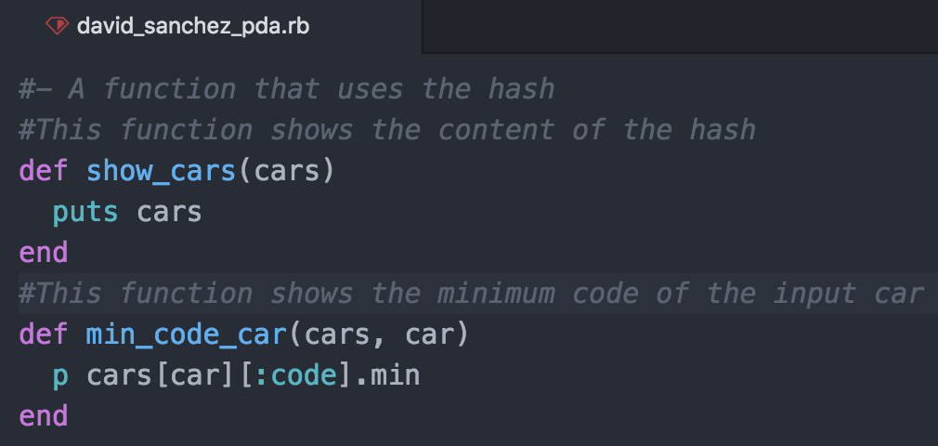

* The result of the function running

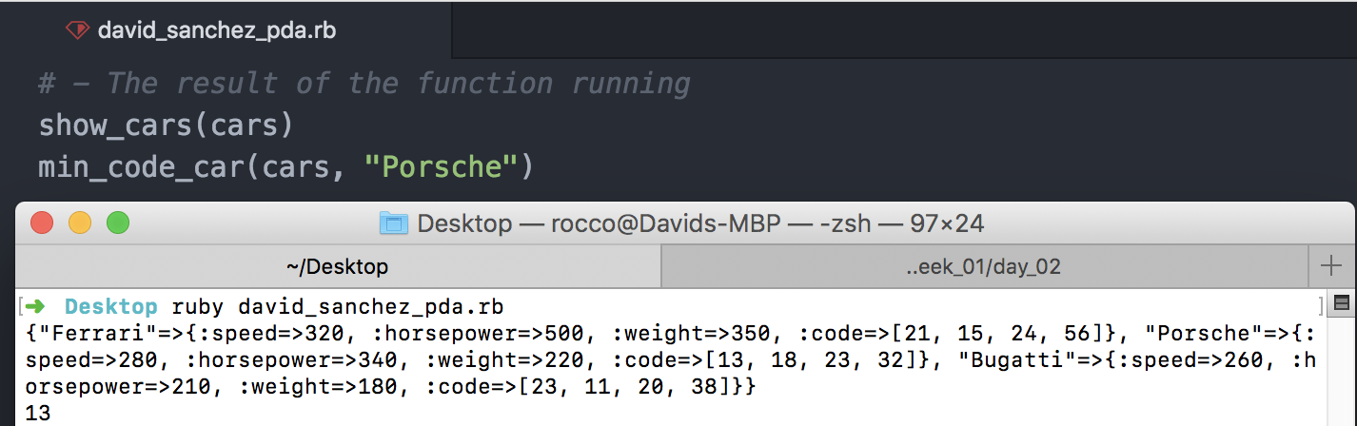

**Ref**: I.T. 3

Demonstrate searching data in a program.

• A function that searches data

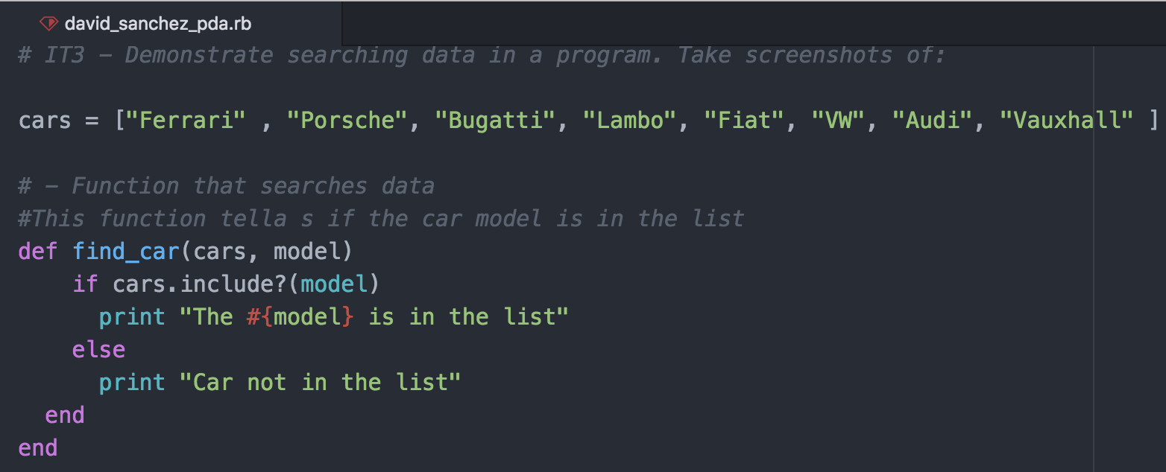

• The result of the function running

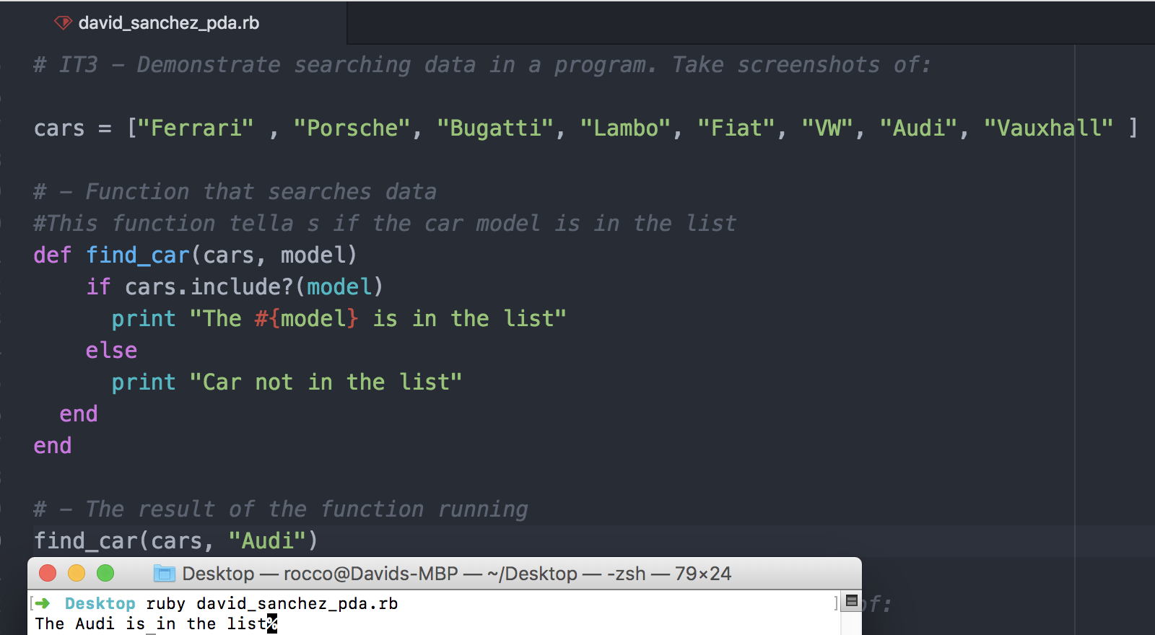

**Ref**: I.T. 4

Demonstrate sorting data in a program.

• A function that sorts data

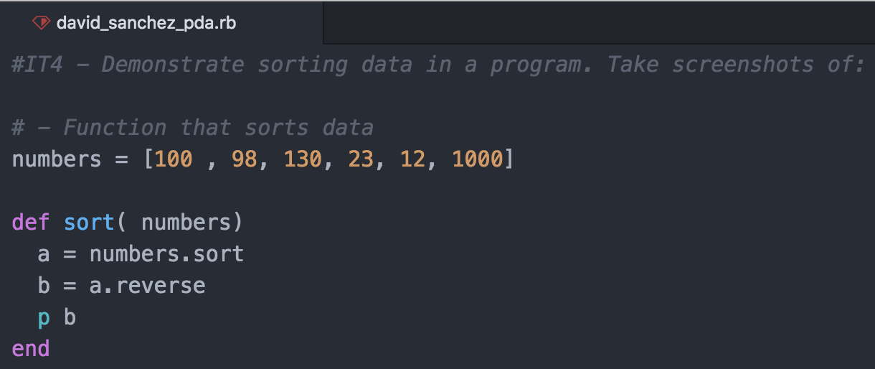

• The result of the function running

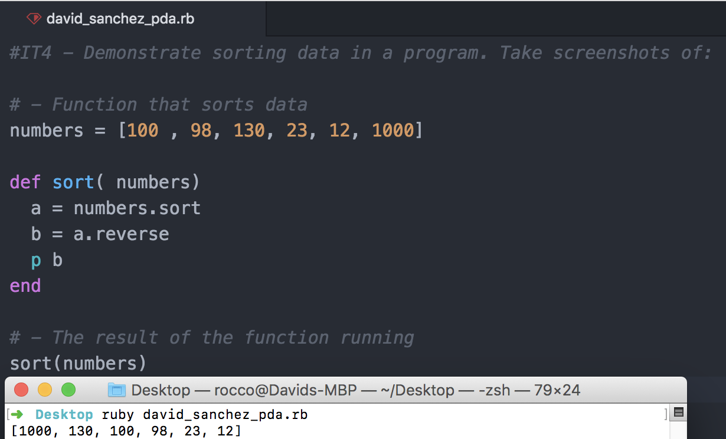

**Ref**: I.T. 7

Demonstrate the use of Polymorphism in a program

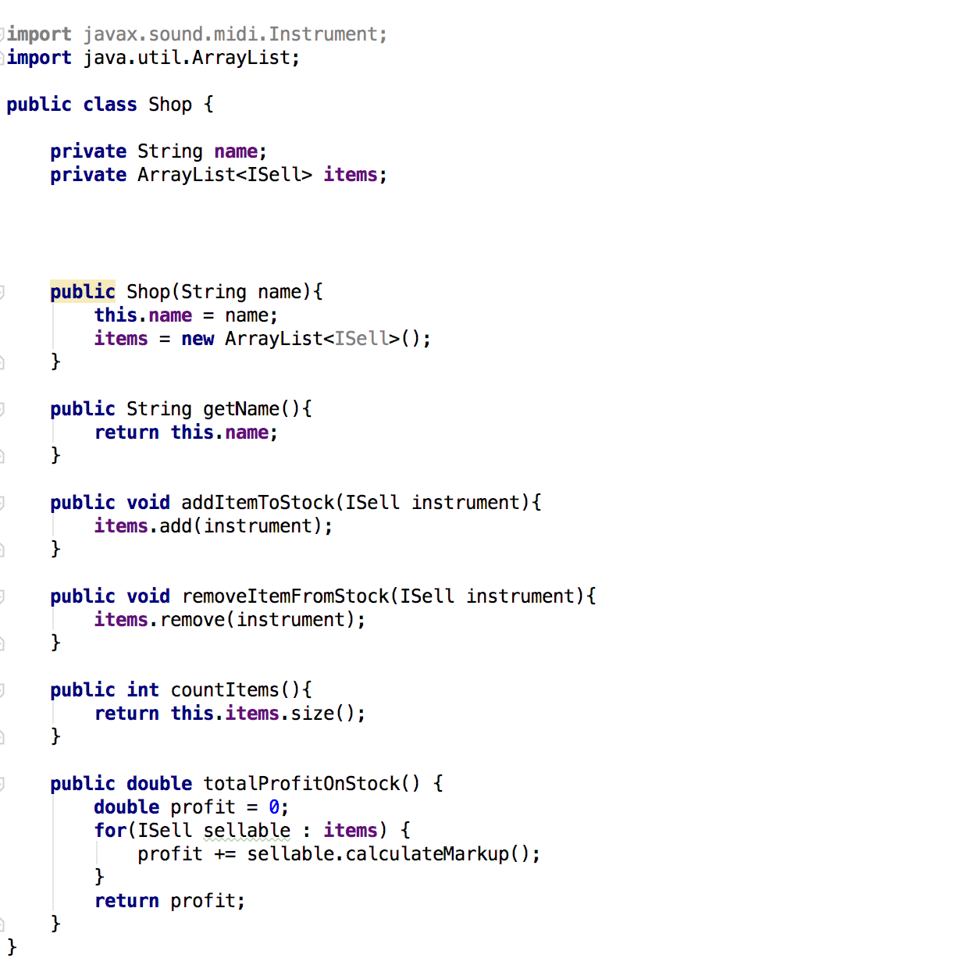

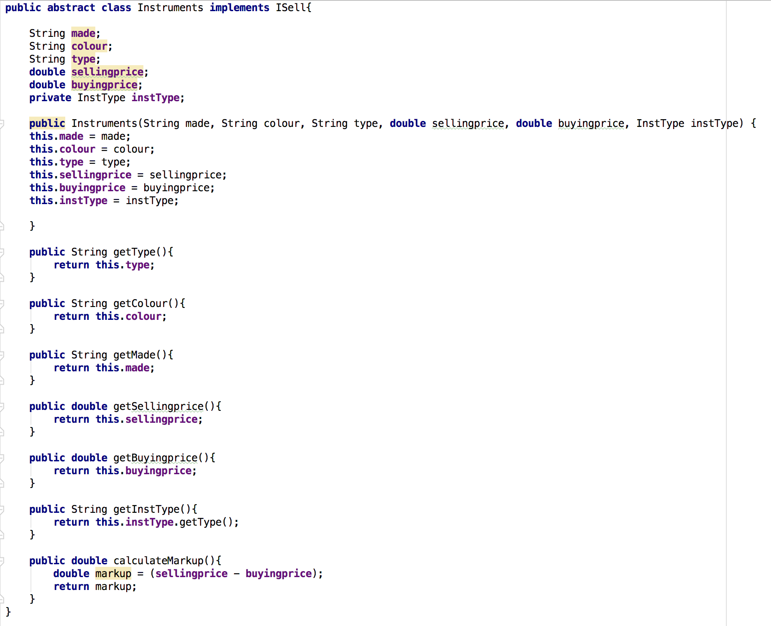

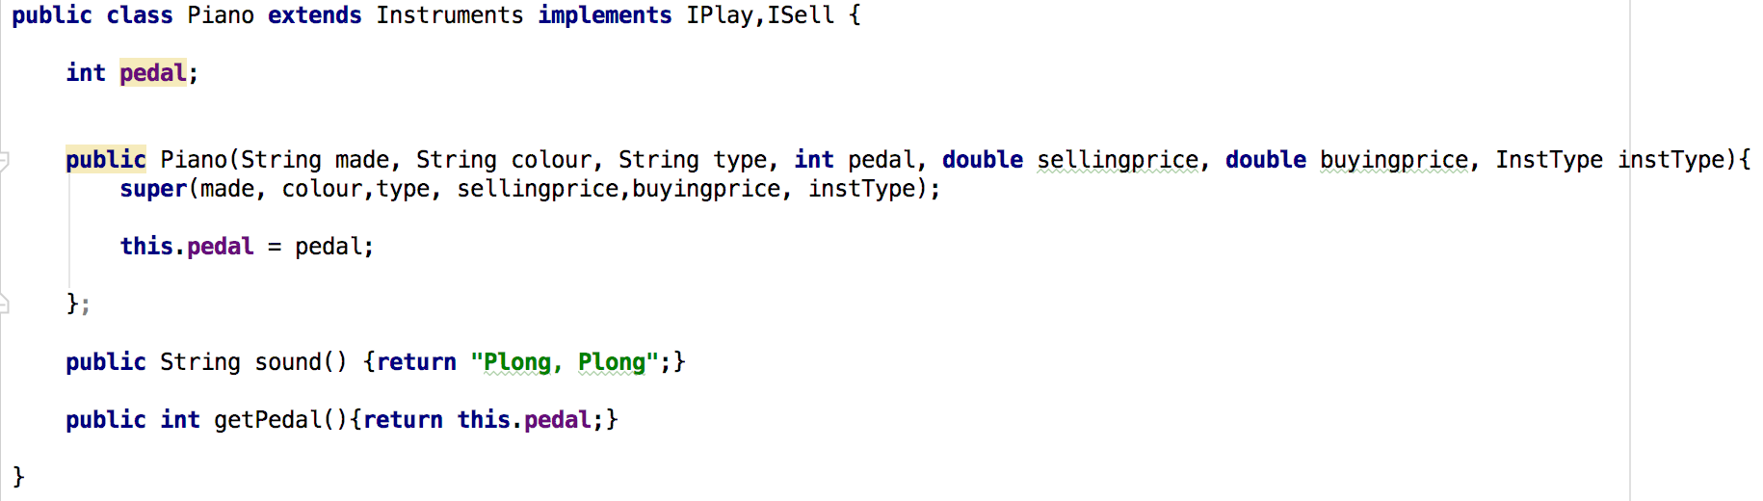

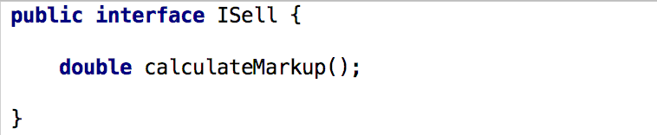

**Ref**: I.T. 1

Take a screenshot of an example of encapsulation in a program

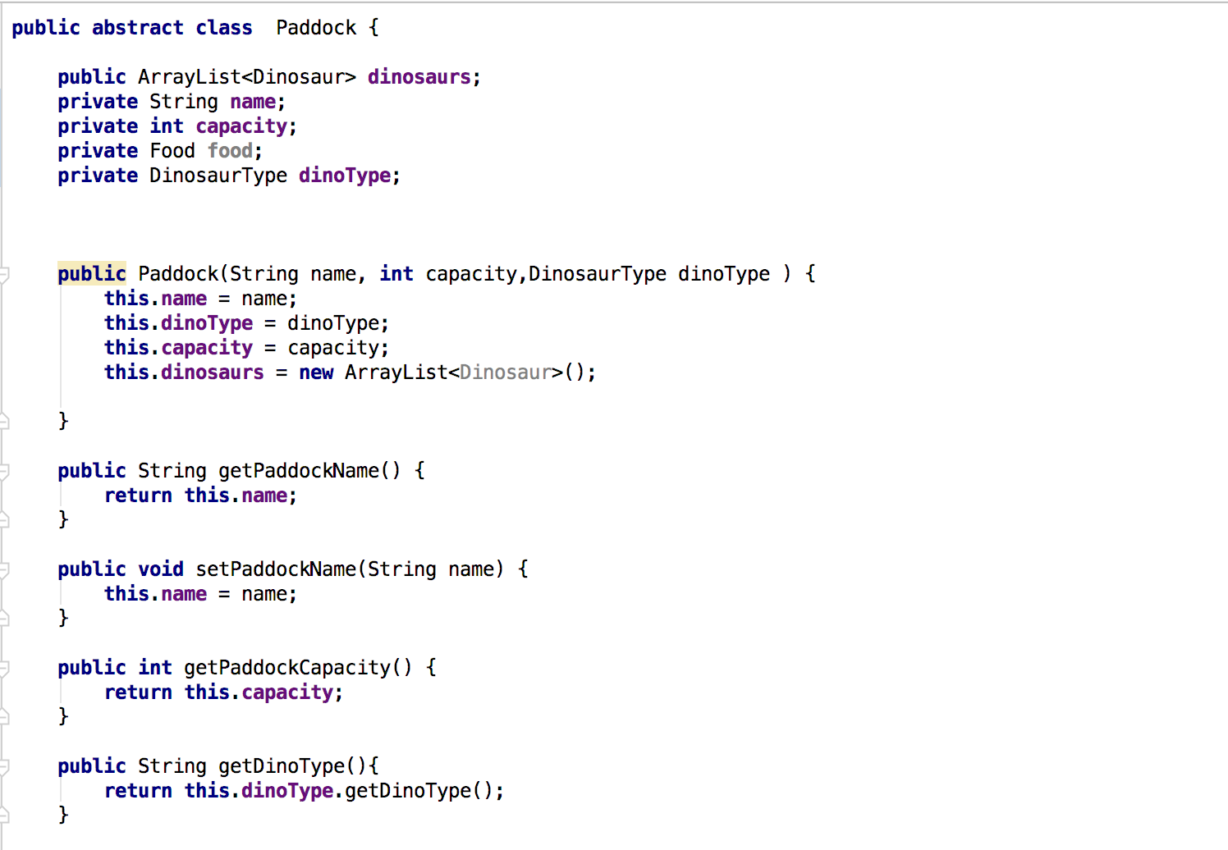

**Ref**: I.T. 2

Take a screenshot of the use of inheritance in a program. Take screenshots of:

* A Class

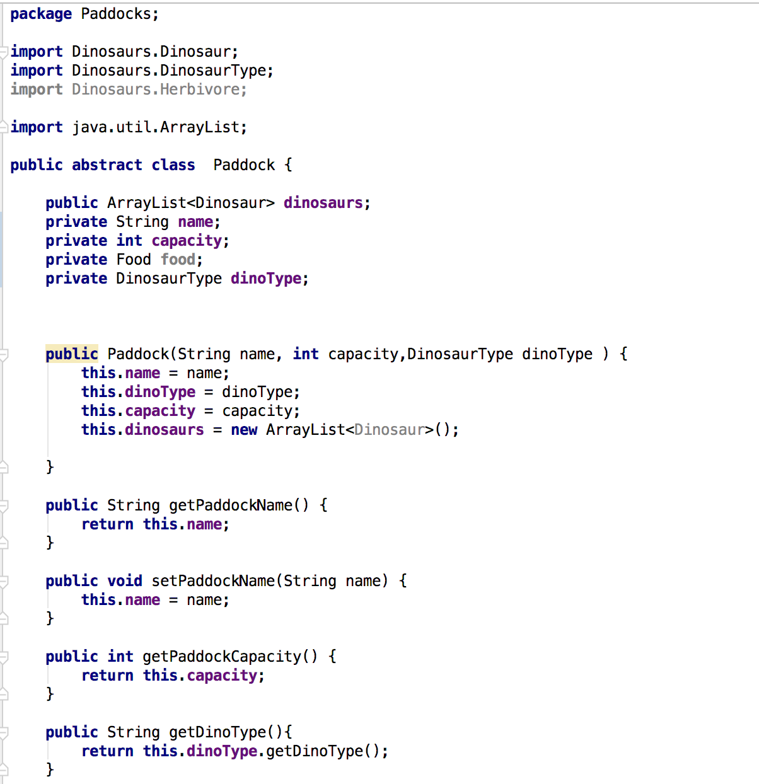

* A Class that inherits from the previous class

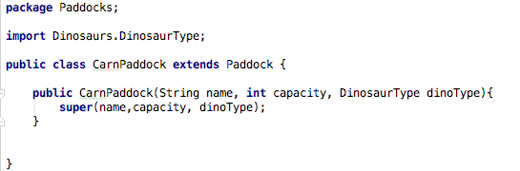

* An Object in the inherited class

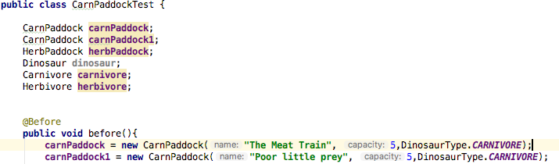

* A Method that uses the information inherited from another class

